# 

C1M1L3 Item06 EXEMPLAR Program Governance

## Step 1: Key roles

Create an organizational chart that outlines the governance structure for the “Digital Transformation 2024-2027” program. Include key roles such as Program Sponsor, Program Steering Committee, Program Manager, and Project Managers:

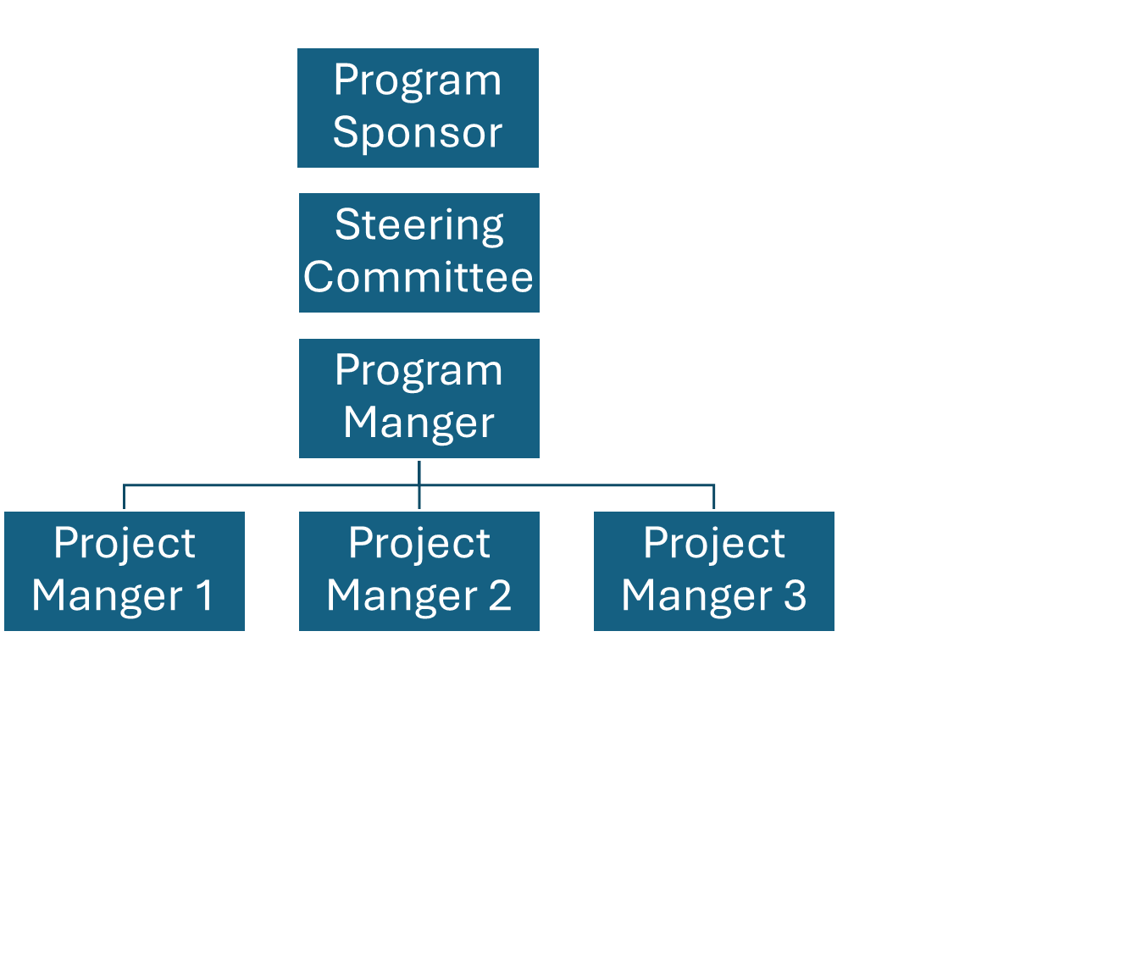

## Step 2: Decision-making matrix

Create a decision-making matrix.

Categorize decisions by the decision type:

* Strategic
* Operational
* Change management
* Risk management

Assign responsibility to the appriopriate level of governance (Program Steering Committee, Project Manager, Program Manager, Executive Leadership Team). Be sure to include the escalation path.

| Decision type | Description | Primary Decision-Maker | Escalation Path |
| --- | --- | --- | --- |
| Strategic | Regarding program scope, objectives, or timelines | Program Steering Committee | Executive Leadership Team |
| Operational | Day-to-day management, including resource allocation and scheduling | Project Managers | Program Managers |
| Change Management | Approval of significant changes impacting the program | Program Manager | Program Steering Committee |
| Risk Management | Identification and mitigation of high-impact risks | Project Managers | Program Manager |

## Step 3: Develop Program Governance framework

List 5 steps to include in a comprehensive “Digital Transformation 2024-2027” program governance framework and provide a brief description.

1. Form a Program Steering Committee to provide strategic oversight and ensure alignment with organizational goals.
2. Define Governance structure to define the communication channels and clear reporting lines between various levels.
3. Define key performance indicators (KPIs) and dashboards to help measure the program's success. Include progress against the timeline, budget adherence, and achievement of business objectives. The dashboard will help provide stakeholders with real-time visibility into program performance.
4. Establish risk management and mitigation processes for successful issue resolution, including escalation paths.
5. Establish regular governance meetings to regularly review progress of the program and address risks and make strategic adjustments to keep the program on track.